Database Project Part 4b

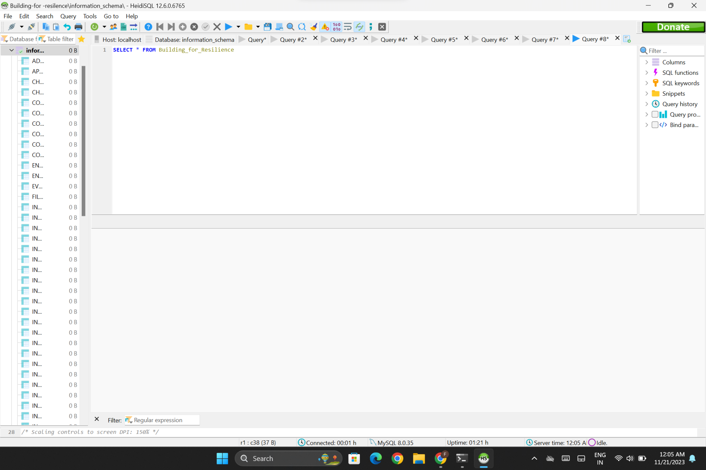

ALTER TABLE Building for resilence_Supplier

ADD COLUMN rating ENUM('null', '1', '2', '3', '4') DEFAULT 'null';

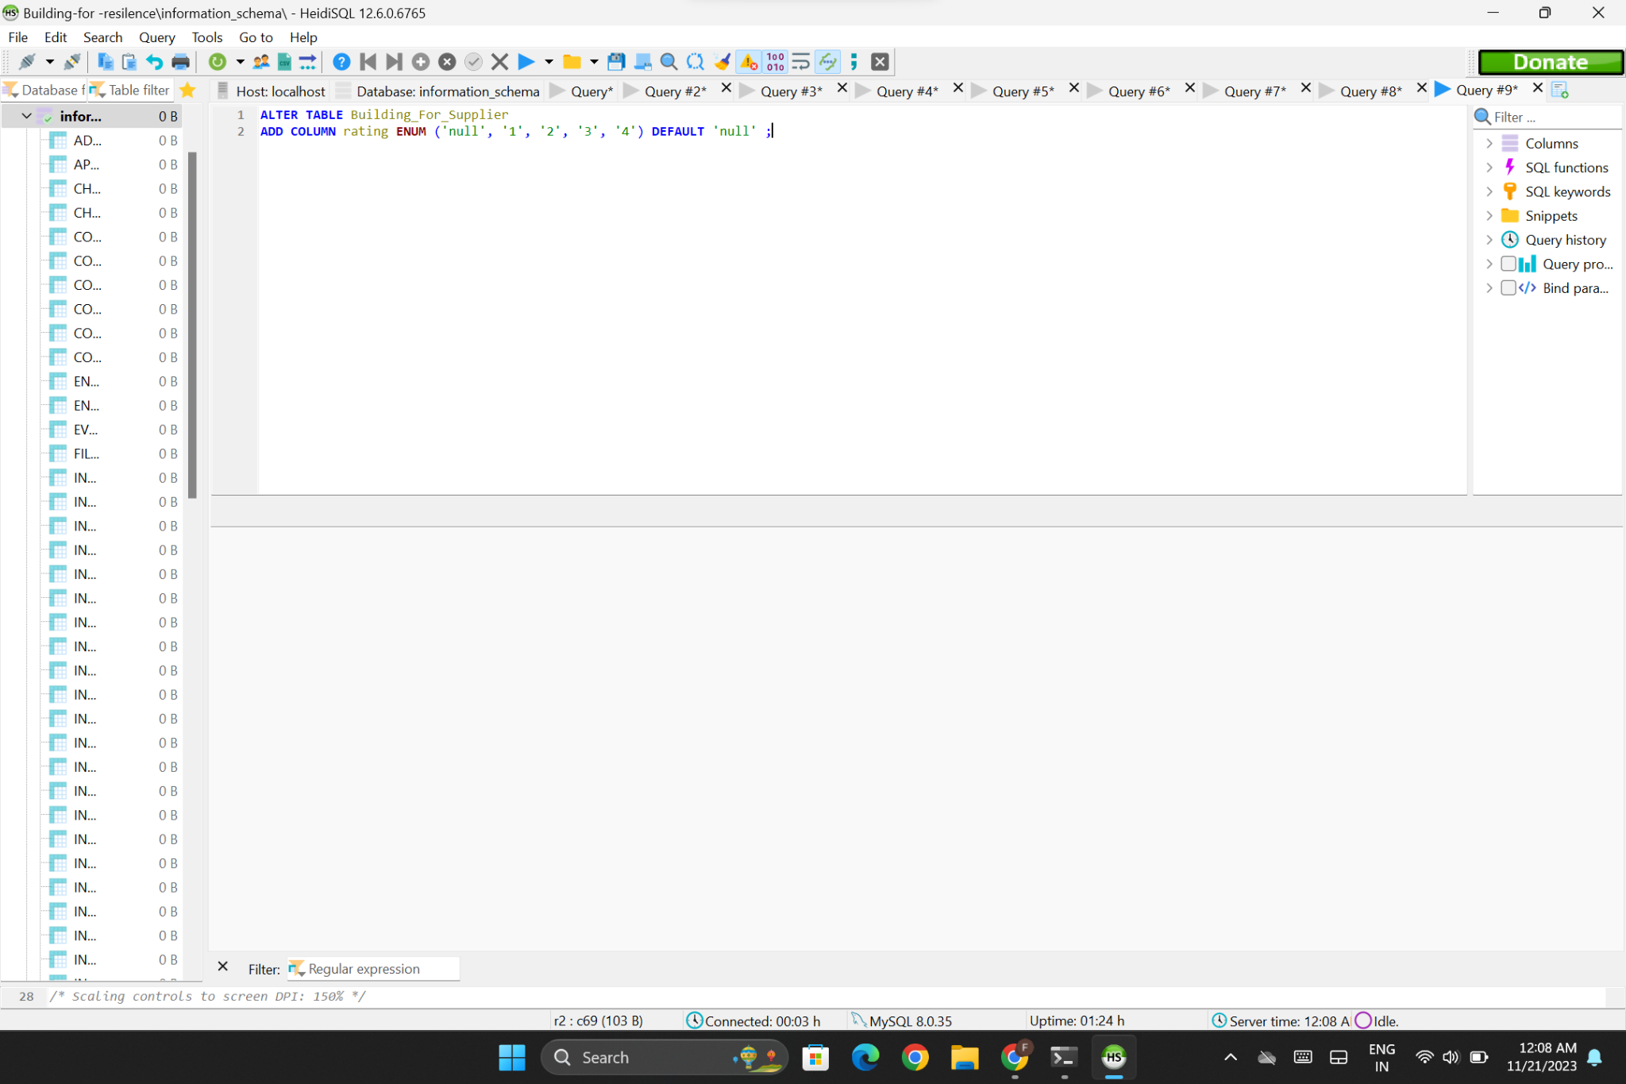

INSERT INTO Building for resilence_Supplier

VALUES ('ABC Bamboo Co.', 'High-Quality', 'Cityville', '123-456-7890', 'abc@example.com', 'Supplier specializing in premium bamboo products');

INSERT INTO Building for resilence_Supplier

VALUES ('ABC Bamboo Co.', 'High-Quality', 'Cityville', '123-456-7890', 'abc@example.com', 'Supplier specializing in premium bamboo products','1');



UPDATE Building for resilence_Supplier

SET Building for resilence_Supplier ='xyz'

WHERE rating = 1

DELETE FROM Building for resilence_Supplier WHERE Building for resilence_Supplier ='ABC Bamboo Co.'

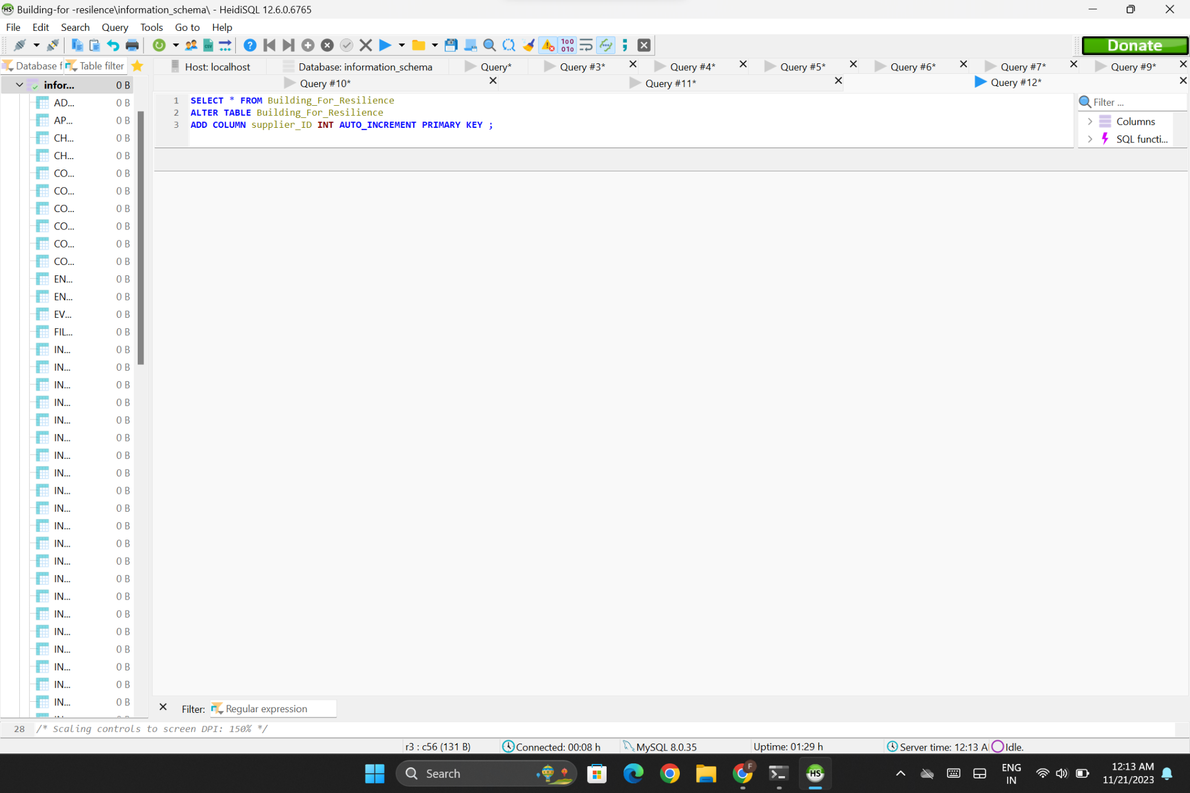

ALTER TABLE Building for resilence_Supplier

ADD COLUMN Building for resilence_Supplier id INT AUTO_INCREMENT PRIMARY KEY;

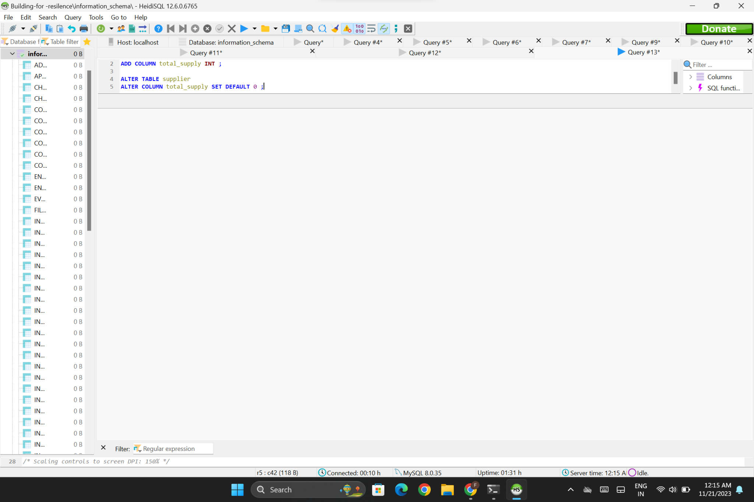

SELECT * FROM Building for resilence_Supplier

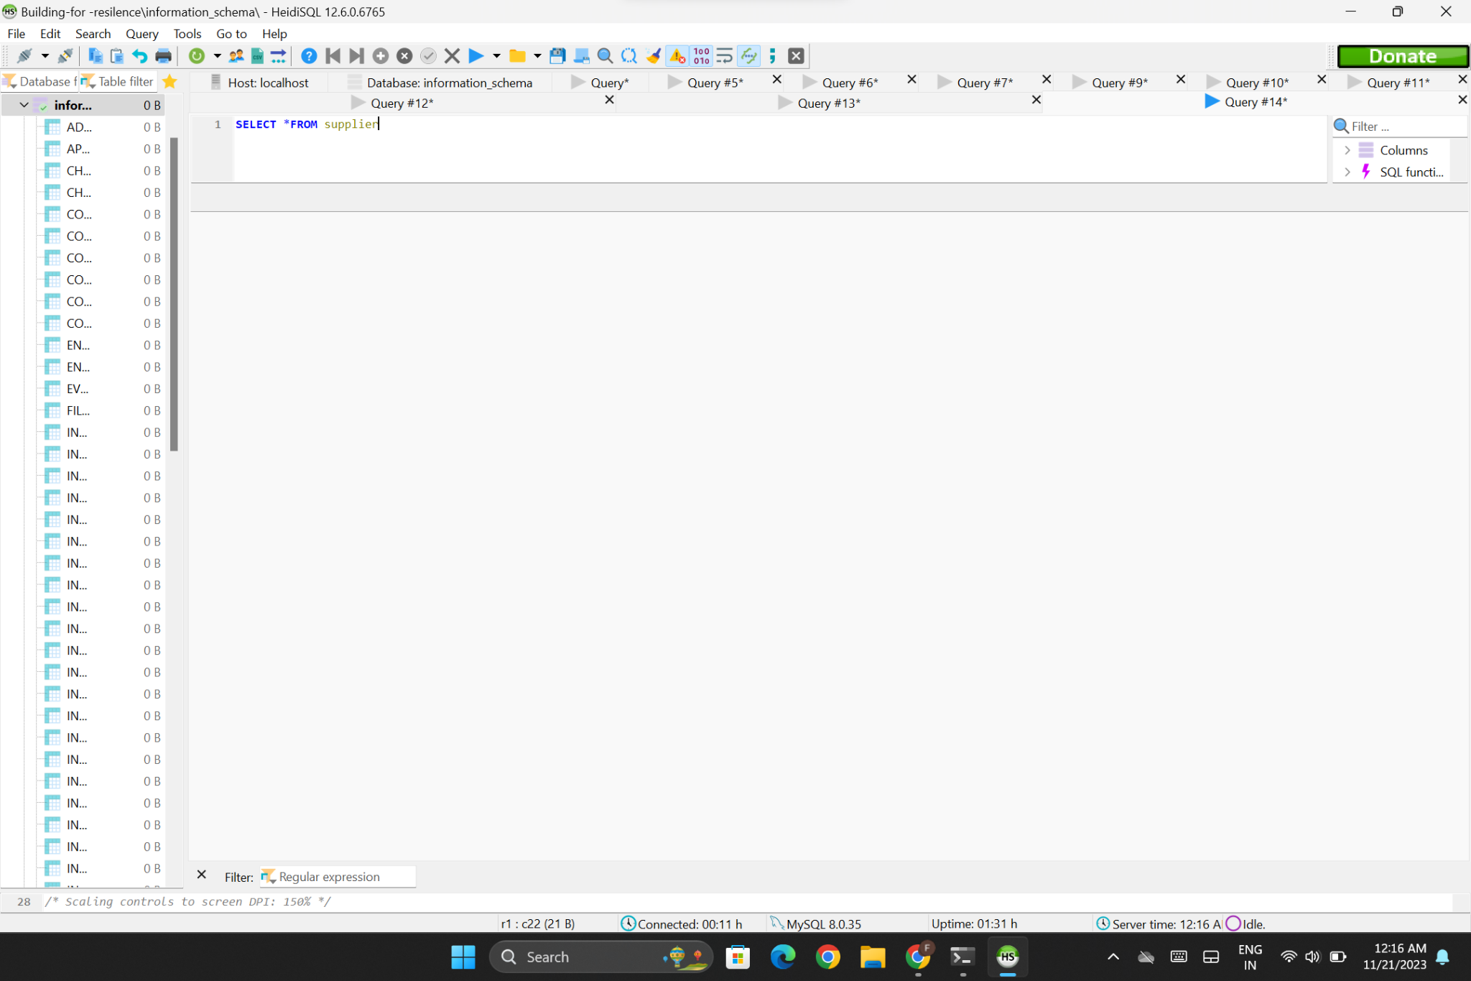

INSERT INTO Building for resilence_Supplier

VALUES ('Co.', 'Premium Grade', '123 Main Street, Cityville', '555-123-4567',

'info@greenbamboo.com', 'A leading supplier of environmentally friendly bamboo products, committed to sustainability and quality.','2','');

SELECT * FROM Building for resilence_Supplier



ALTER TABLE Building for resilence_Supplier

ADD COLUMN total_supply INT;

ALTER TABLE Building for resilence_Supplier

ALTER COLUMN total_supply SET DEFAULT 0;



SELECT * FROM Building for resilence_Supplier



INSERT INTO Building for resilence_Supplier

VALUES ('Bamboo', 'Premium Grade', 'Texas', '7878',

'info@greenbamboo.com', 'rating is very good.','2','','');

SELECT * FROM Building for resilence_Supplier

